1. Introduction

Giflytics is a new software system that allows marketers to track the performance of the GIFs that they create and upload to GIPHY. Giflytics will have two distinct tools: GIF Tracker and GIF Keywords. GIF tracker is an analysis tool that helps marketers understand performance (ranking) in search results, while GIF Keywords in a planning tool, that helps marketers perform keywords research and discover relevant, low competition keywords to tag their GIFs with in order to increase the overall exposure and impressions of their GIFs.

Giflytics offers several advantages after it is fully developed. The most apparent advantage is that these tools do not currently exist from any other company in the GIF industry. Currently, there is no easy way for marketers to understand the ranking of their GIFs in search results. When marketers run GIF marketing campaigns, they keyword planning process has to be done by manually searching keywords in a GIF search engine and looking at what other similar, popular GIFs are using for keywords. There is no automated way for marketers to understand the competition of each keyword and assess their ability to rank.

Brands have begun to invest a small portion of their marketing budget into GIFs for marketing purposes. However, these brands and the marketers that run GIF-based marketing campaigns, lack the ability to fully understand how well their GIFs are performing. Currently GIPHY only gives users the number of impressions (shares) each of their GIFs earn. This number is helpful, but leaves marketers wanting to better understand how their GIFs perform compared to competitors. Giflytics software tool GIF Tracker allows marketers to input the URL of their publicly available GIF and be able to see where it ranks in search results.

2. Architecture

Giflytics is a web application that uses a client-side and a server-side system. The client-side is presented as a web application that will translate all of the user’s requests, while the server-side system will calculate statistics, handle login authentication, and store all uploaded data from the user. Users will be able to access the application via a supported web browser by going to the domain the web application is hosted on.

Major Inputs:

- User Information (account credentials for login)
  - Email: Account Email for accessing the application.
  - Password: Hidden key used with Email to log into a users account.

- Gif IDs from GIPHY:
  - A short sequence that is assigned to every GIF image on GIPHY. Inputting this via the upload component allows a user to process their data through Giflytics, allowing us to run queries on their GIF images.

- Keywords:
  - Any number of keywords can be assigned to a GIF on GIPHY. Users may input any number of keywords to track for each GIF image they upload through Giflytics.

Major Outputs:

- Gif Analytics
  - Gif Metadata: (Includes information about the gif itself)
    - Name: The name of the GIF on GIPHY.
    - Images: A set of still images to display on the front end of Giflytics
  - Gif Keyword Rank: (Information about the statistics of a gif)
    - Keyword Rank: For each day that a keyword is being tracked, Giflytics will fetch and calculate the rank of a keyword it is compared against other GIFs. Rank is determined by relevancy. Eg: A GIF that holds rank 400 on ‘pizza’ for a given day means it was the 400th result on GIPHY when searching for GIFs under that keyword.

3. Use Cases
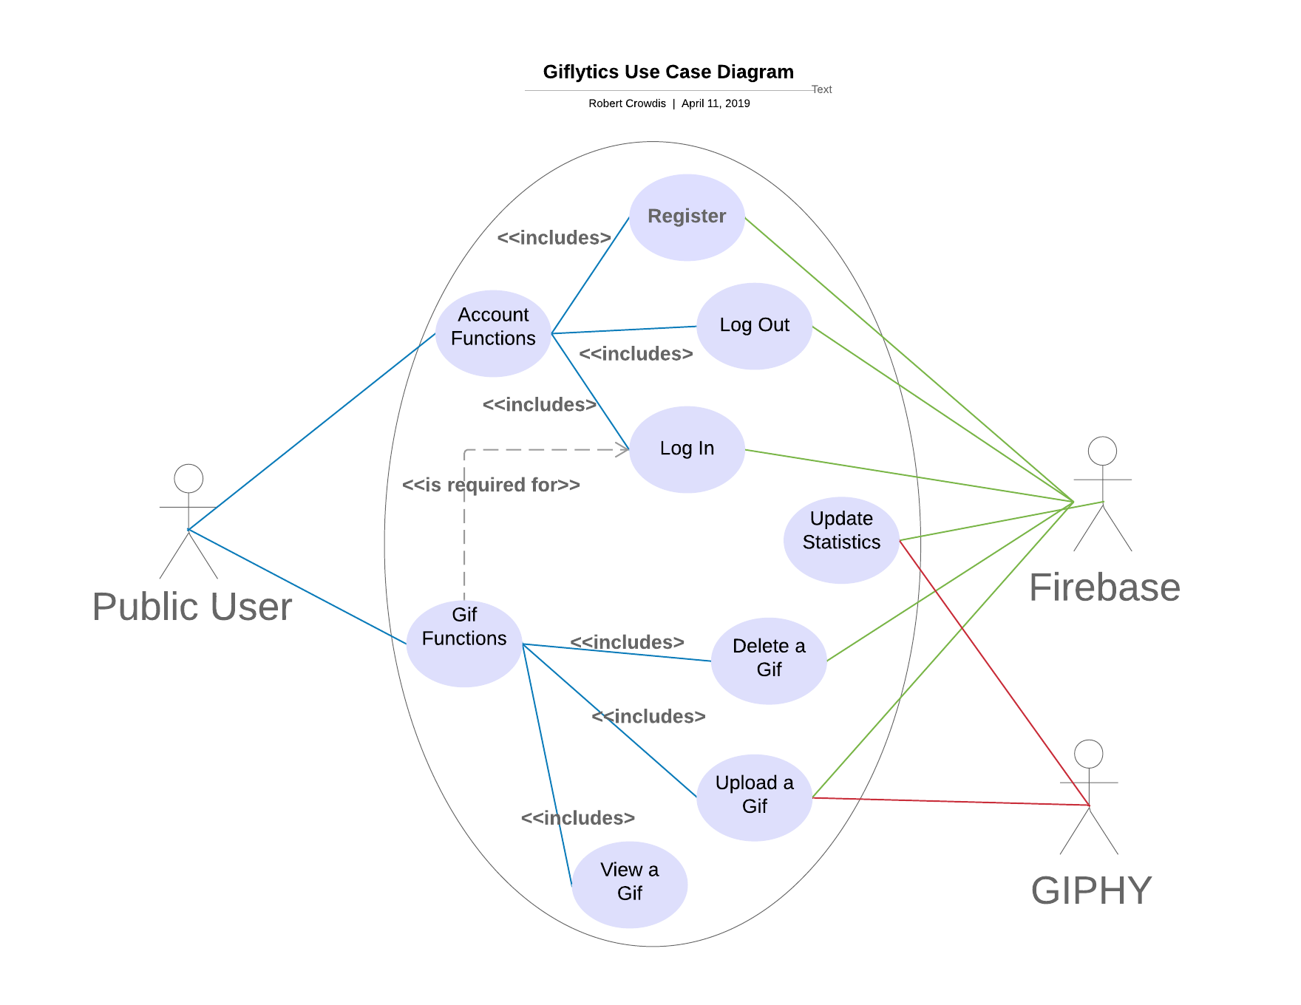
Overview: This is a general graph of all the possible interactions with Giflytics.

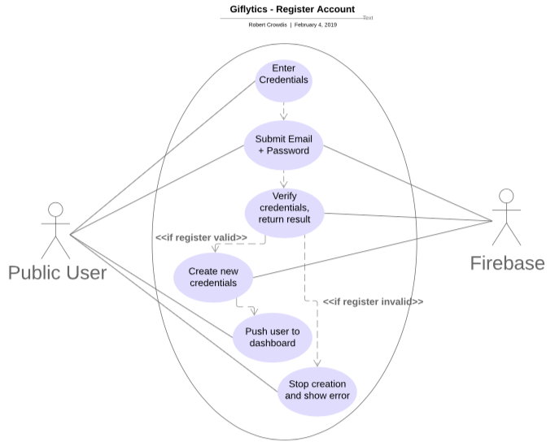

Register Account: A user wishes to register an account with Giflytics. They enter their email and password (along with a repeated password field) and press submit to make an account. Once Firebase receives the request, it checks to see if the credentials meet all requirements (email not in use, password is strong enough). On success, the user is logged into Giflytics and sent to the main dashboard – otherwise, they are prompted to make corrections and their account is not created.
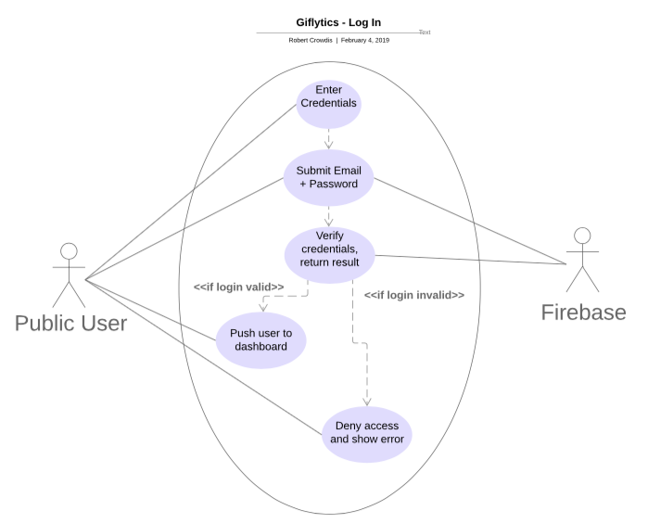

Log In: A user wishes to log into their Giflytics account. They enter their email and password and press submit to send a request to Firebase. Once Firebase receives the request, it checks to see if the credentials match. On success, the user is logged into Giflytics and sent to the main dashboard – otherwise, they are prompted to make corrections and their log in request is rejected.
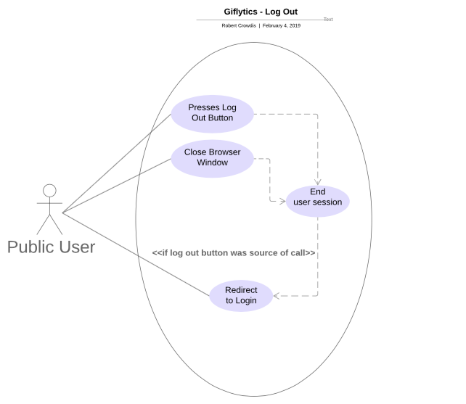

Log Out: When a user wants to log out, they may either close the browser or press the ‘log out’ button. If the ‘log out’ button is pressed, the user is redirected to the Log In screen. The users session is considered invalid with Firebase if they attempt to pass any route guards or interact with Firebase.
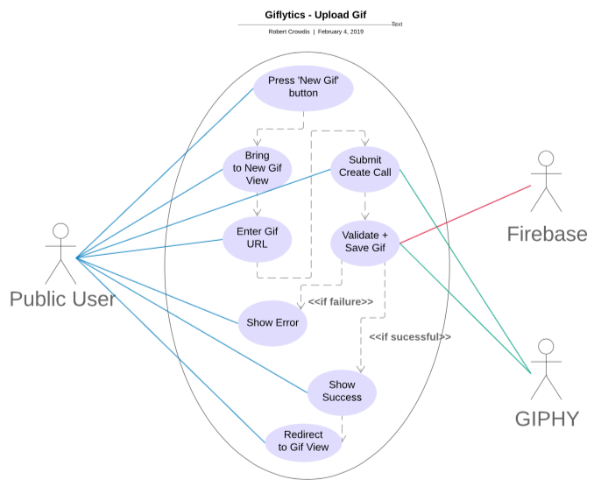

Upload Gif: A user begins by pressing the ‘New Gif’ button found on the Dashboard or sidebar of the application. They are brought to a modal that asks for a GIPHY url to process. Once a url is added and ‘upload’ is pressed, GIPHY is queried to grab all relevant gif information. If the GIF is invalid or could not be found, an error is shown and the user must retry with a new url. Otherwise, the GIF information is fetched and sent to Firebase to be uploaded under the user’s account. A success message is then shown and the user is sent to a new page with information about their newly uploaded GIF.
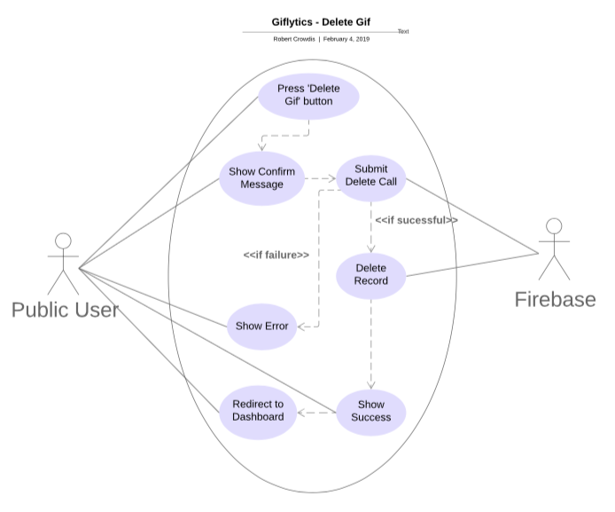

Delete GIF: A user wants to delete a GIF from their account. Under the ‘Gif View’ screen the user may press the ‘Delete GIF’ button, and after going through a confirmation modal will send a request to Firebase to delete the related records. If there is a problem with the request, the user will be shown why the GIF could not be deleted at this time. Otherwise, all related records will be purged and the user will be sent back to the Dashboard screen.
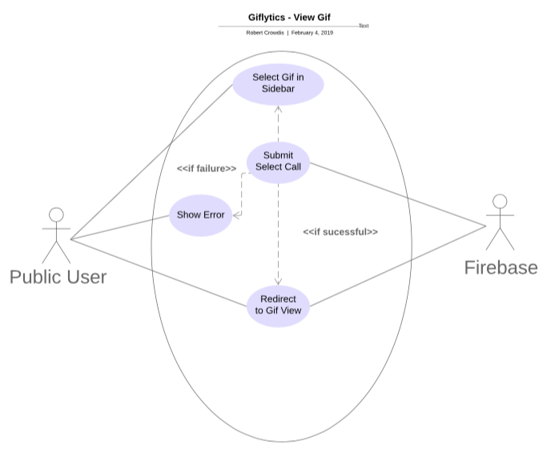

View GIF: A user wishes to view statistics and details about a particular GIF image they have uploaded. They begin by selecting a gif on the sidebar. Firebase will attempt to populate any fields or information that is missing. If an error occurs, it will display a message to the user and stop their route activities. Otherwise, the user is redirected to a view of that GIF.

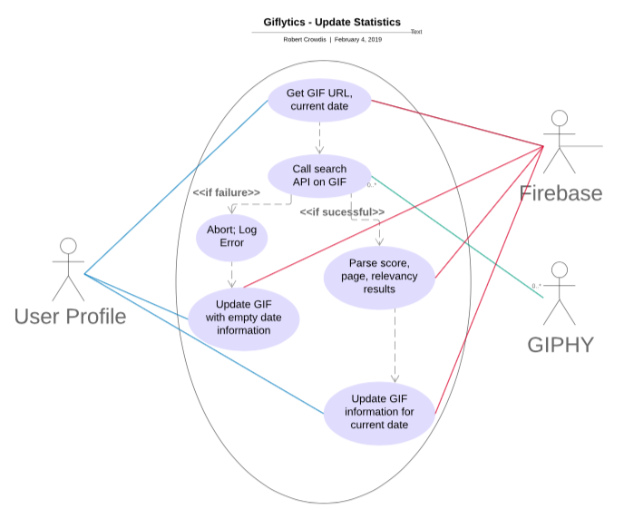

Update Statistics: Every 24 hours Firebase runs a CRON job on each GIF in the database, using its saved GIPHY url and the current date. Each keyword on a GIF is queried by a search request on the GIPHY API. Should GIPHY return an error, the statistics for that day will not be updated. Otherwise, the relevancy for each GIF is parsed out and uploaded into the database for the user to analyze.

4. Data

User information is stored via the Google Firebase Authentication section.

- Gifs: Category that holds MANY Gif records (hundreds)
  - 4353jbdffjn35ng (Example GIF Record)
    - created {number} Time record was created in milliseconds.
    - gid {string} Gif id assigned by GIPHY.
    - id {string} id assigned by Firestore.
    - slug {string} Combined name + GIPHY gid.
    - title {string} Name of GIF assigned by GIPHY.
    - uid {string} User id who uploaded the GIF.
    - url {string} url to the GIF image.
    - user {JSON} holds information related to GIPHY user account.
    - Images {JSON} holds information related to GIF frames.
    - Tags {CATEGORY} holds keyword information.

- Tags: Category that holds MANY keyword records (thousands)
  - Angry bananas (example tag name)
      - name {string} Keyword name.
      - id {string} Gif id that keyword is assigned to in Firestore.
      - created {number} Date created held in milliseconds.
      - ranking {JSON} Hash map of all the rankings recorded.
  - lets party
      - name {string} Keyword name.
      - id {string} Gif id that keyword is assigned to in Firestore.
      - created {number} Date created held in milliseconds.
      - ranking {JSON} Hash map of all the rankings recorded.
5. User Interface Design
User Interface Design was contracted through an outside designer. They were created only for concept of the application – final product will NOT be one-to-one and is created ONLY by myself.

Login Screen / Create Account: Users who arrive at the website will land on this page. There is the option to log in if you already have an account, or make one by selecting the ‘Create Account’ (as shown below) which will show a modal to sign up. If a user attempts to navigate to a page without being logged in, they will be redirected to this form.
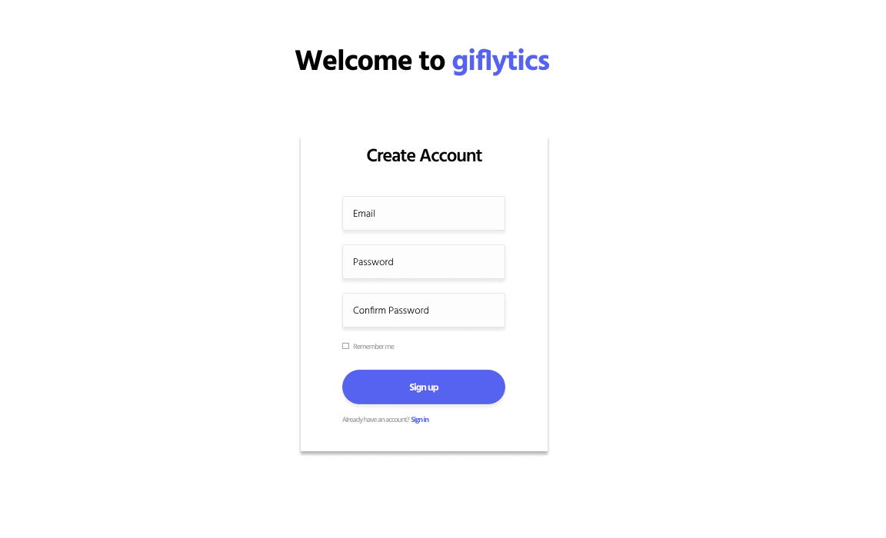

Home Screen, no gifs. After logging in for the first time, the user will see this page. They are prompted to upload some gifs so that the application can be used as intended. If a user deletes all their GIFS, they will also end up on this page.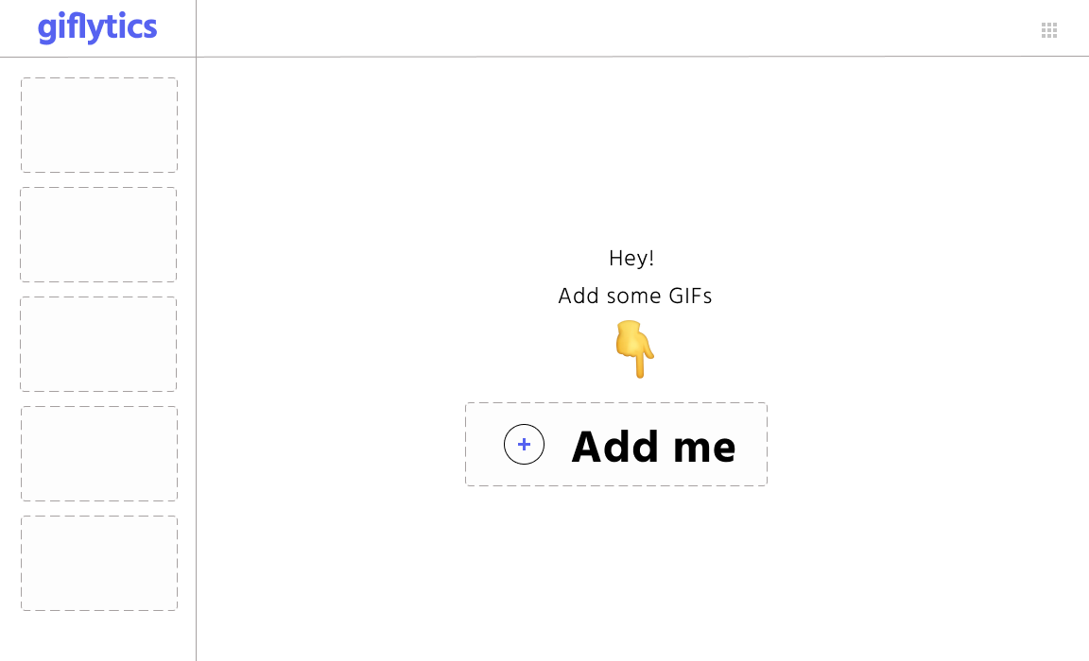

Home screen, after uploading Gifs. Users will see a table for each GIF that they have uploaded. A sidebar on the left hand side allows users to select uploaded GIFS for more detailed analytics.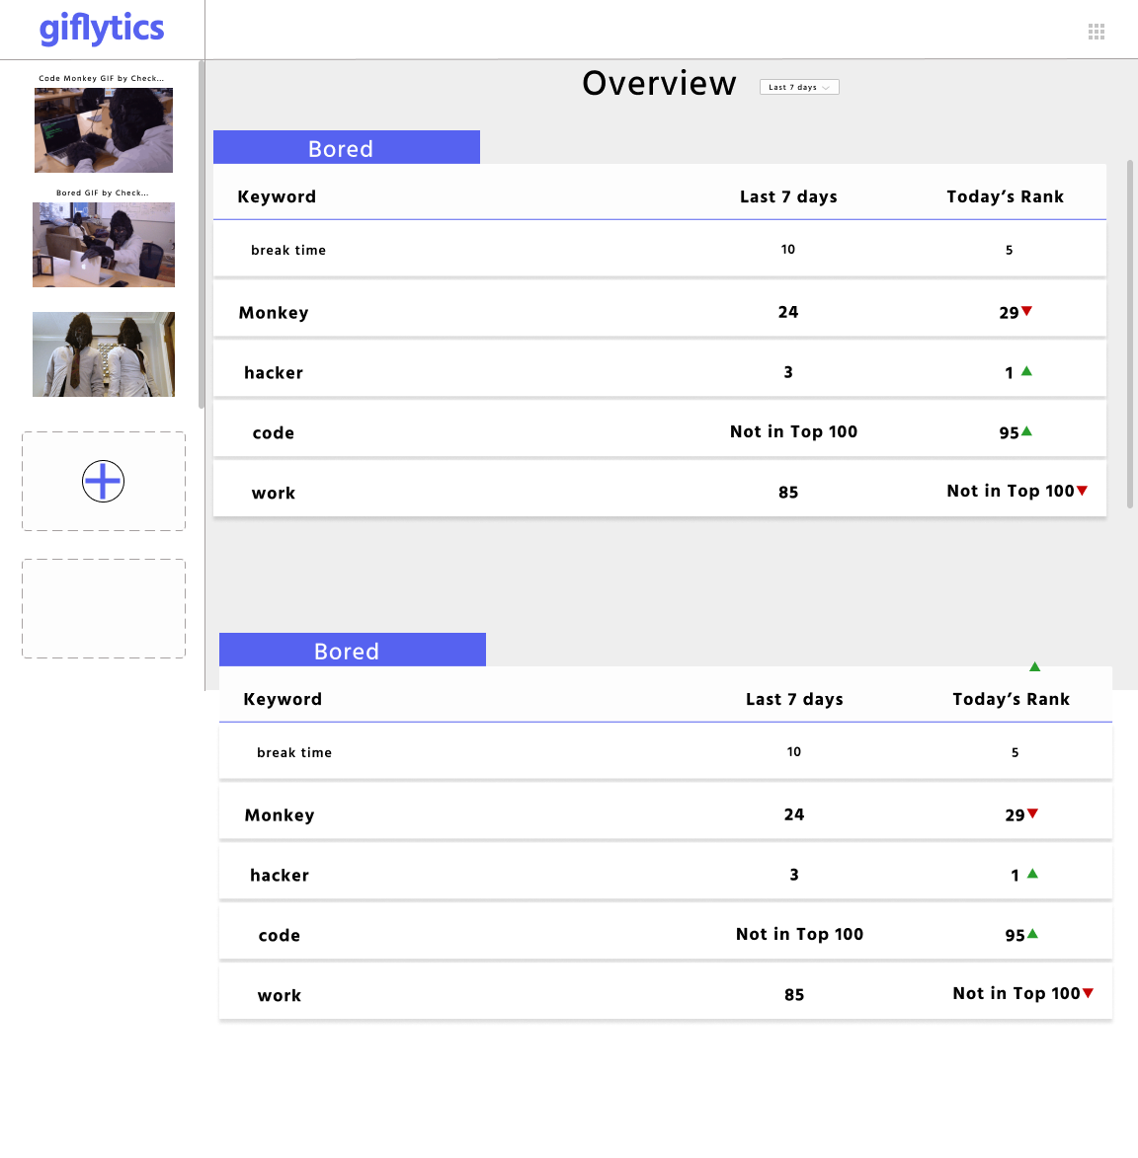

Upload Modal: By selecting the “Upload GIFs” option, you will be prompted to upload a GIF via an overlaid modal, as shown below. After uploading, the user will be redirected to the Keyword Modal to enter some keywords to track.

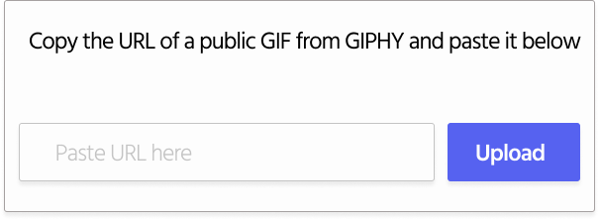
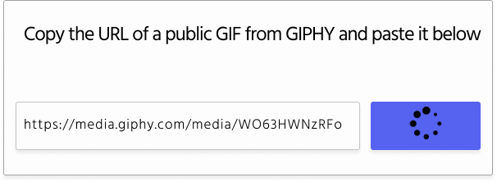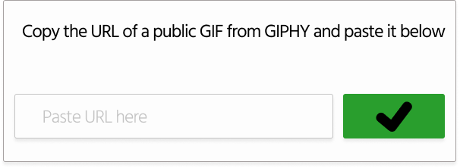

Keywords Modal, after Uploading Gif: After successfully uploading GIFs, users may add any number of keywords to track. Once successfully added, this modal closes and brings the user back to the overview.
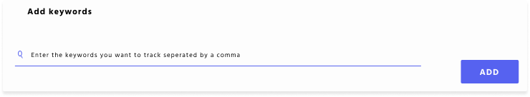

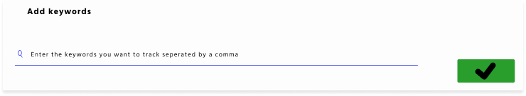

6. Detailed Workplan
Deadlines to meet: A short Gantt timeline containing all the deadlines for this project to meet this semester.

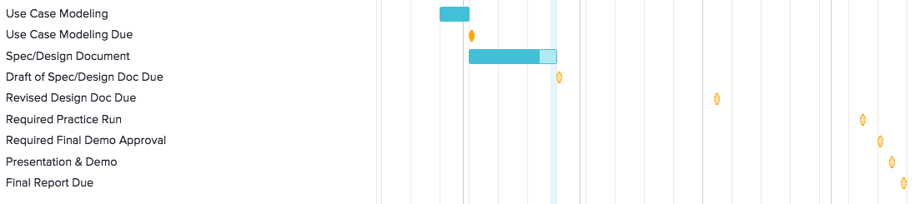

Weekly Sprints: Each week is accompanied by a new feature. Some sprints continue for more than one week, but are divided appropriately across the time this semester lasts.

